Closely related to the [Fibonacci Sequence](http://en.wikipedia.org/wiki/Fibonacci_number) (which you may remember from either your school maths lessons or Dan Brown's The Da Vinci Code), the Golden Ratio describes the perfectly symmetrical relationship between two proportions.

Approximately equal to a 1:1.61 ratio, the Golden Ratio can be illustrated using a Golden Rectangle. This is a rectangle where, if you cut off a square (side length equal to the shortest side of the rectangle), the rectangle that's left will have the same proportions as the original rectangle.

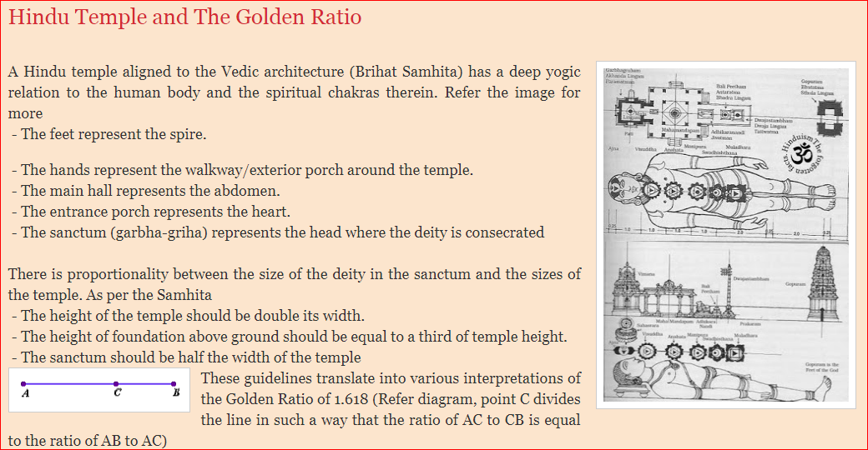

<http://ojoswibasu.blogspot.com/2015/07/hindu-temple-and-golden-ratio.html#:~:text=%2D%20The%20height%20of%20the%20temple,a%20third%20of%20temple%20height>.



<https://in.pinterest.com/lucyjay01/fractals-in-art/>



<https://www.simplifyingtheory.com/math-in-music/>

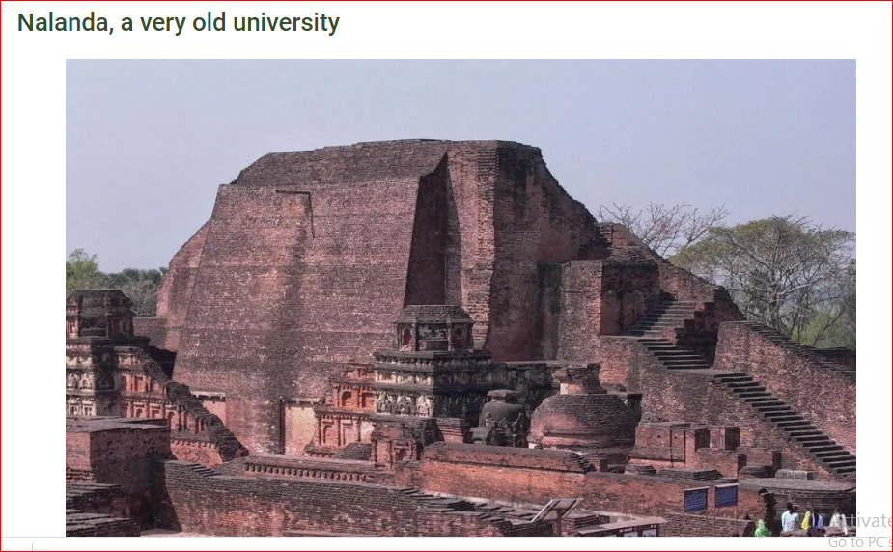

The Buddhist monastery complex at Nalanda, in today’s Indian state of Bihar, was a center of learning founded in the fifth century CE. Archaeological excavations which begun in 1915 has revealed temples, lecture and meditation halls, libraries and gardens, together with a trove of sculptures, coins, seals and inscriptions. Subjects taught here included the Vedas, logic, Sanskrit grammar, medicine, fine arts, astronomy, mathematics, politics and epistemology. Above all, however, it was a center of Buddhist learning which flourished under the Gupta empire, 240-590 CE. [Read more: “[Indian mathematics](http://ringmar.net/irhistorynew/index.php/2018/10/28/indian-mathematics/)“] Much of our knowledge of Nalanda comes from the writings of Chinese monks who came here to study in the seventh century. At the height of its prominence the university had some 2,000 professors and 10,000 students who all were accommodated in dormitories. Nalanda was the first educational institution to conduct entrance exams. The fortunes of the university declined after the Gupta rulers and in the 1190s it was destroyed by invading armies from Central Asia.

Al Quaraouiyine, in Fez, Morocco, is sometimes said to be the oldest university in the world, founded in 859 CE. [Read more: “[Ibn Rushd and the challenge of reason](http://ringmar.net/irhistorynew/index.php/2018/10/13/ibn-rushd-and-the-challenge-of-reason/" \t "_blank)“] The oldest universities in Europe – Paris and Bologna, founded in the thirteenth-century CE – are far younger. Nalanda is older than all of them. However, while Nalanda was destroyed, Al Quaraouiyine has been in continuous operation for close to 1,200 years. Yet since 2014 Nandala University is once again accepting students. Led by Amartya Sen, a Nobel Prize winning economist, and with economic support from various Asian countries, its aim is to once again to become Asia’s leading center of learning. Subjects taught here include ecology, history economics and languages. Buddhism is taught too but features less prominently on the curriculum than once was the case. The hope is that Nandala University can help contribute to the economic development of Bihar which is one of India’s poorest regions.

<http://ringmar.net/irhistorynew/index.php/2018/10/27/gupta-gold-coins/>

https://youtu.be/eXhZisI2Ds4